David Horth

[Email address]

Abstract

This document describes the installation and operation of the find camera application.

Find Cameras Application

Application notes for FindCameras

Contents

1 Application Name 3

2 Version 3

3 Purpose 3

4 Prerequisites 3

5 Installation 3

6 Operation 4

6.1 Authentication 4

6.2 Load Cameras 4

6.2.1 Properties 5

6.2.2 Thumbnail 5

6.3 Export 6

6.4 Copy URL to Clipboard 6

7 Known Issues 6

Revision History

**Revision Date Author Description**

|  |  |  |  |
| --- | --- | --- | --- |
| 1.0 | 10-21-2013 | DHORTH | Initial Revision – Rough Draft |
| 1.0.1 | 10-31-2013 | DHORTH | Initial Revision – Draft 2 |
| 1.0.2 |  | DHORTH | Header & Footer and minor cleanup |
|  |  |  |  |
|  |  |  |  |

# Application Name

Find Cameras

# Version

1.0

# Purpose

Connects to the specified VSM enumerates all the cameras and creates a ciscosource url for each camera. It provides a convent way to get valid ciscosource urls for all the cameras on a VSM.

# Prerequisites

Microsoft .Net framework 4.0 (full)

# Installation

Unzip all the FindCamera.zip package into a local directory.

# Operation

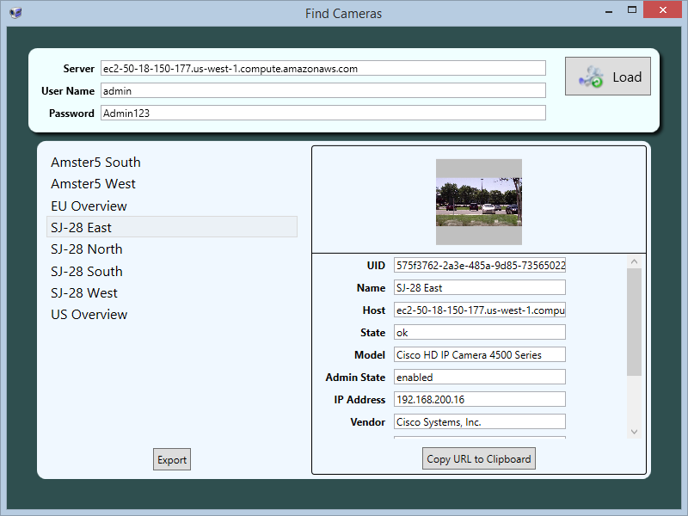

## Authentication

* Server – The name or ip address of the VSM server
* User Name – User name for a valid account on the VSM server
* Password – The password for the above account

## Load Cameras

The cameras button will attempt to enumerate all the cameras associated with the specified server. The first step is to authenticate with the VSM. Once authenticated we ask the camera service on the VSM for a list of camera. We retrieve the camera list 100 at a time. Once we have the list we walk each camera and get a security token. This token is valid for 60 minutes before it expires. Once we have a security token the camera is added to the list, and a background thread is started to attempt to retrieve a thumbnail image

### Properties

Any of the properties can be cut and pasted. Standard windows copy paste select commands are available in the boxes.

#### UID

Unique identifier for the camera. This field is include in the url

#### Name

The name of the camera

#### Host

The name/ipaddress of the VSM. This is part of the URL

#### State

The cameras current state, good is ‘ok’ bad is ‘critical’ (need more info)

#### Model

The model of the camera.

#### AdminState

#### IpAddress

The actual IP address of the camera

#### Vendor

The vendor of the camera

#### Token

The security token for the camera, this is valid for 60 minutes. Part of the URL

#### ObjectType

Device_vs_camera_ip

#### RtspUrl

A valid RTSP address to the camera. NOTE this is only valid as long as the security token is valid. You cannot store and reuse this URL it must be created fresh each time.

#### CiscoUrl

A valid address for our direct show filter. Note that unlike the "RtspUrl" this address is valid and can be stored. Since the security token is not part of the URL the filter we use the connection information to get its own security token

### Thumbnail

After the camera has been discovered a background thread will go out and attempt to get a thumbnail picture from the video stream. Once available the picture will be shown in the left hand side detail pane.

## Export

The export command will create a comma separated file with all the camera properties including both a cisco url and an rtsp url. The operator will be prompted as to where to save the file.

## Copy URL to Clipboard

The copy to clipboard command will copy the cisco url property to the windows clipboard.

# Known Issues

1. The current version only supports secure connections (ie https)
2. There is no support for a LDAP domain server
3. At this time I am unable to determine the width and height of the video stream, so I set the size to 1920x1080